**What are the different exceptions you came across in Selenium?**

**I faced different exceptions as**

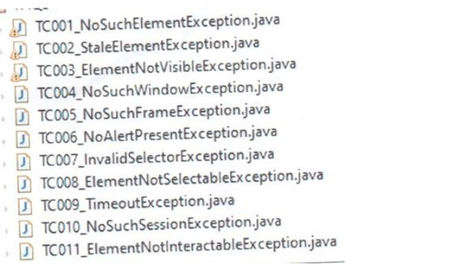

**Coming to No such Element Exception issue,** If the web driver is unable to locate the web element on a web page, it will throw no such element exception.

To fix this issue, we have to modify the locators with the correct xpath, ID, Name and CSS selector. So, like that we can fix no such element exception issues.

**Coming Stale Element Exception Issue**

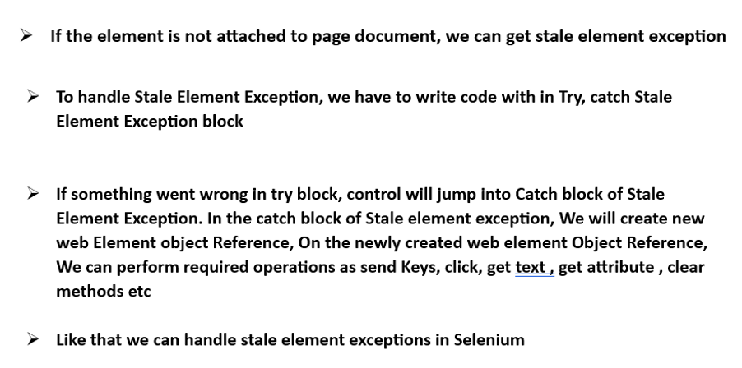

**Coming to timed out exception issue**, if a web element is not loaded with in the specified explicit wait time, Web driver will through timed out exception issue.

To fix this issue. We will revisit the explicit wait time window and we will increase the explicit wait time. And we will rerun the scripts again, so like that we fixed timed out exception issues.

**Coming Element click intercepted exception.** Indicates that a click operation could not be properly executed on a web element

To fix this issue. We are scrolling at that particular web element by using JavaScript executor.

And we are using explicit wait condition as Until element to be clickable.

And we used JavaScript executor or Actions class to click that particular web element.

Like that we fixed element click intercepted exception issue by writing code in try catch blocks

**Coming to Invalid selector Exception,** when a web driver is unable to locate an element with Xpath expression Syntax is incorrect. It will throw invalid selector exception.

To fix this issue. We have to write correct xpath syntax as per the syntax .

Like that we can fix Invalid selector exception issue

**Coming to No such window exception.** If we are trying to perform driver commands on the previously Window or tab? Which was closed already. Then we can get no such window exception issue. To fix this issue, we have to make sure set of driver commands should write prior to closing of the web driver window / tab session.

Like that we can fix No such window exception issue

**Coming to no such frame exception issue**, if a web driver is unable to locate the frame name or Invalid Web Element reference or invalid index reference While switching it to the frame, Web Driver it will throw no such frame exception issue.

In our application frames are loading very slowly on the web page

To fix this issue , we had used explicit wait condition as

Wait<WebDriver> wait = **new** WebDriverWait(*driver*, Duration.*ofSeconds*(20));

wait.until(ExpectedConditions.*frameToBeAvailableAndSwitchToIt*("frameName"));

*driver*.switchTo().frame("frameName");

and to fix this no such frame exception issue , we have to make sure with the correct frame name , correct web element object reference and correct index reference while switching into the frame

Like that we fixed No such frame exception issues

**Coming to No alert present exception issue ,**

When there is no alert on the web page during the execution , Web Driver will throw no alert present exception.

To fix this issue. We used explicit weight condition as.

Wait<WebDriver> wait = **new** WebDriverWait(*driver*, Duration.*ofSeconds*(20));

wait.until(ExpectedConditions.alertIsPresent());

so like that we fixed no alert present exception issue

**Coming to element not selectable exception** Indicates That the web element is present in the web page but cannot be selected. Whenever a drop down of the web element Is not loaded Within the select class. Then this kind of element not selectable exception issue will occur.

To fix this issue we had written code in nested try catch blocks

In the first try block. We had written explicit weight condition as element to be clickable.

Follows with catch block as timed out exception.

and in the nested try block we had written code as Select drop down equal to new select of driver. Find element by ID. Follows by catch block as web driver exception. So, like that we had fixed this kind of issue by using nested try catch bocks

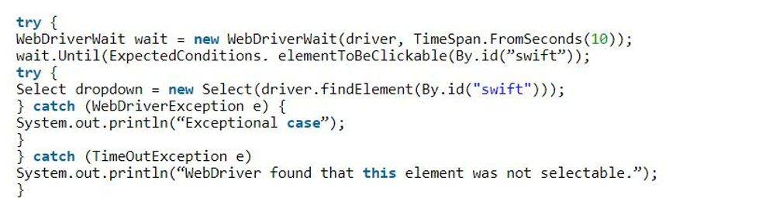

**Coming to element not visible exception,** When Web driver tries to perform an action on an invisible web element and Which cannot be interacted with it or the Web element is in a hidden state. Then element not visible exception issue will occur. To fix this issue.

we had written code in nested try catch blocks

In the first try block. We had written explicit weight condition as Visibility of element located by ID and follows with catch block as timed out exception.

and in the nested try block we had written code as driver. Find element by ID. Follows by catch block as web driver exception. So, like that we had fixed this kind of issue by using nested try catch bocks

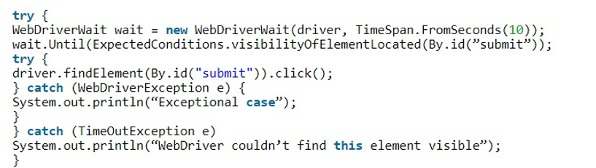

**Coming to no such session exception** occurs only after driver session is closed and when we try to execute set of driver commands system will throw an exception as no such session exception.

To fix this issue we have to make sure, set of driver commands must have to write prior to Session closing.

